Subject: The Upstanders Survey
Dear (Student Body/Community),

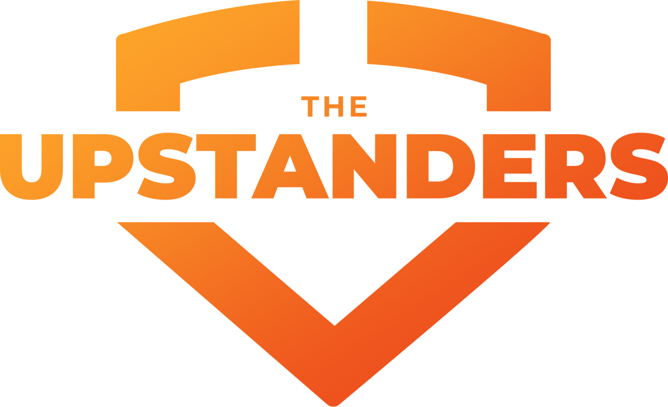

We hope that you found The Upstanders enlightening and helpful.

Please complete the post-screening survey here. It should take about 5 minutes to complete.
(insert your survey link)

To learn more, and access some of the resources that came with the screening, please visit indieflix.com/education/upstanders/resources

We’d love to hear from you! If anything came up that you’d like to discuss as a result of watching The Upstanders, do get in touch with ……… at (insert email address).

We wish you all a kind and happy week,

